USER GUIDE
PARATRANSIT SERVICE



Your information
STL customer number:
OPUS card number:
Please notify the STL Customer Contact Centre if you get a new OPUS card and make sure you register your OPUS card to protect it against loss, theft or damage.
- For all travel-related inquiries:
Reservations Centre: 450-973-3111

TO BOOK A TRIP:
8:00 a.m. to 7:00 p.m., 7 days a week
To cancel or change a trip, or to check the estimated time of arrival for your trip:
Monday to Thursday and statutory holidays: 5:00 a.m. to 1:00 a.m.
Friday: 5:00 a.m. to 2:00 a.m.
Saturday: 5:30 a.m. to 2:00 a.m.
Sunday: 5:30 a.m. to 1:00 a.m.
- For information about our services or for comments, complaints, and requests
Customer Contact Centre:
450-688-6520
Hours:
Monday to Friday: 7:00 a.m. to 7:00 p.m.
Saturday, Sunday and statutory holidays: 8:00 a.m. to 5:00 p.m.
STLaval.ca

Table of Contents

At your service 6
Our mission 6
Our values 6
The STL Quality Commitment 7
Services 8
Service area 9
Paratransit fare zones 9
Booking a trip 10
Types of trips 10
Regular trips 10
Occasional trips 10
Limitations 10
Zones 11
Same-day reservations 12
Statutory holidays and Christmas holidays 12
Required information when booking a trip 13
Service disruptions 14
Will-call returns 14
Trip cancellations 15
No-shows 15
Trips to have a second wheelchair repaired 16
Transfer options 16
Travelling with a support person 17
On the paratransit network 17
On the regular transit network 17
Accessible services on the regular transit network 18
Mobility device specifications on the regular network 19
Riders with limited mobility 19
Fare information 20
Payment methods 20
Paratransit paper tickets 21
Credit and debit card 21
Cash 21
Monthly pass loaded onto your OPUS card 21
Protecting your OPUS card 22
VIRTUAL monthly pass 22
How to obtain a virtual monthly pass 23
Points of sale – Single tickets and monthly passes 23
On-time performance and pickup 24
Imminent vehicle arrival 24
On-time performance 25
Delayed service 25
Boarding 25
Before boarding 25
Vehicle arrival 25
Assistance 26
Eligibility card 26
Assistance provided by drivers 27
Location accessibility 28
Your responsibilities 29
Stay seated in your mobility device during the trip:
Conditions and safety 30
Use of a three- or four-wheel scooter 31
Using a wheelchair without tie-downs 31
Seat belts 31
Service animals and pets 32
Guide or service dogs 32
Pets 32
Carry-on items 33
Exceptions for certain destinations 34
Additional information 35
Behaviour on board paratransit vehicles 35
Trip duration 36
In the event of an accident 36
Your record 37
Updating your record 37
Moving outside of Laval? 38
Visitors 38
Tips 38
Feedback and penalties 39
Feedback 39
Penalties 39
Contact us 40
For all travel-related inquiries 40
Lost and found 40
For information about our services or for comments,
complaints and requests 41
To submit your eligibility form 41

At your service

At the STL, we have one simple goal: to give you the best transit experience possible. That’s why we provide professional, courteous and attentive service to help you get around Laval and the surrounding areas. This guide explains how our paratransit service works.

Our mission
The STL’s mission is to build and operate a high-quality local public transit service that is innovative, efficient, and flexible enough to meet our customers’ changing mobility needs.

Our values

RESPECT, EXCELLENCE and COLLABORATION
Our values define everything that we do to keep our customers happy and make our employees proud.

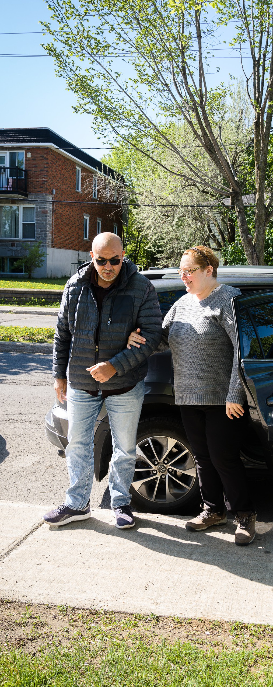

The STL Quality Commitment
At the STL, we place great emphasis on the quality of our services. To prove it, we have developed a quality commitment that all of our team members have pledged to honour—both on the road and at our call centre.
The five principles of the STL Quality Commitment:
  - We will provide friendly and courteous service.
  - We will pick you up within the scheduled window.
  - We will make every effort to ensure a safe and comfortable ride.
  - We will provide you with accurate, relevant information.
  - We will keep our vehicles clean and in good working order.

Services

The STL provides door-to-door paratransit service between accessible departure and destination locations to meet the transportation needs of eligible customers. Rides on paratransit vehicles are available by reservation only.
As this is a shared-ride service, we are counting on everyone to be on time so we can always stay on schedule.
Paratransit service uses regular taxis, accessible taxis, and accessible vans.
We offer different types of transportation depending on our customers’ limitations.
Drivers are responsible for assigning seats in vehicles based on each customer’s specific needs. Seats are assigned based on the information in the customer’s file and the scheduled passenger pickups and drop-offs listed on the driver’s manifest.

We will do everything we can to provide rides when you need them and make sure our vehicles accommodate your requirements.

Service area
The STL provides paratransit service within the City of Laval and across the Greater Metropolitan Area served by the Autorité régionale de transport métropolitain (ARTM).

Paratransit fare zones
A Agglomeration of Montreal
B Agglomeration of Longueuil and Laval
C Northern and southern suburbs
D Outside the ARTM service area
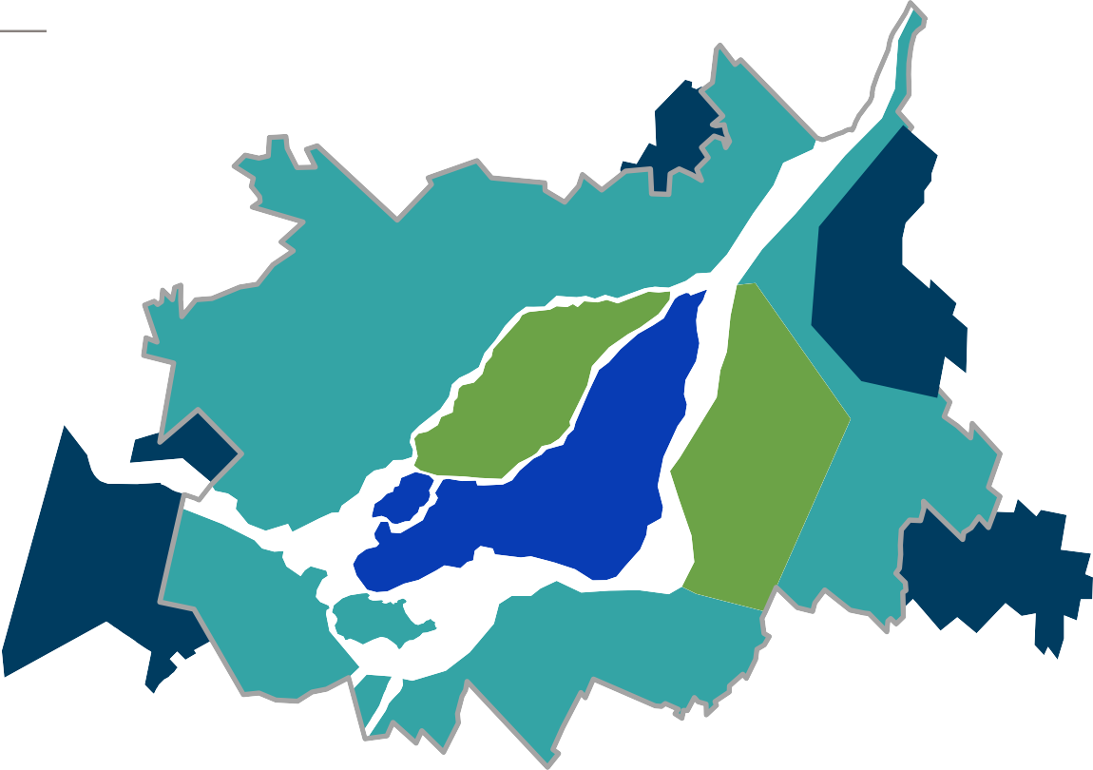
ARTM service area

C
B
B C
A
D
D

Booking a trip

Types of trips

Regular trips
Regular trips are repeat trips that occur at the same time and originate and terminate at the same scheduled location.
To provide the best possible service, we reserve the right to make changes to regular trip requests several times a year. If your confirmed pickup windows change, we will contact you to let you know.

Occasional trips
Occasional trips are one-time trips taken on specific dates.

Limitations
Paratransit service is intended for single riders only. We do not provide charter services, school bus services for trips organized by public or private elementary or secondary schools, and transfers between medical facilities for the purpose of receiving health care.

Effective January 6, 2026

 | Destination
 | Laval – Zone B | Montreal – Zone A | Longueuil and Zone C (North Shore and South Shore)
Reservations  for planned occasional trips  [450-973-3111, option 1] | Reservations can be made  7 days in advance until 7:00 p.m. the day before the trip | Same as Zone B | Reservations can be made 7 days in advance until 12:00 p.m.  the day before the trip
Cancellations  and ride-related inquiries  [450-973-3111, option 2] | Monday to Thursday and statutory holidays: 5:00 a.m. to 1:00 a.m.  Friday: 5:00 a.m. to 2:00 a.m.  Saturday: 5:30 a.m. to 2:00 a.m.  Sunday: 5:30 a.m. to 1:00 a.m. | Same as Zone B | Same as Zone B
Operating hours Sunday to Thursday | First pickup: 6:00 a.m.  Last drop-off: 12:30 a.m. | Same as Zone B | Same as Zone B
Operating hours Friday and Saturday | First pickup: 6:00 a.m.  Last drop-off: 1:30 a.m. | Same as Zone B | Same as Zone B
Will-call returns (status) | Not allowed  Exceptions: If your medical appointment or court appearance ends earlier than planned and more than 60 minutes before the scheduled return time,  we will assess the situation based on vehicle availability.  To call for a return trip,  dial 450-973-3111, option 2. | Same as Zone B | Not allowed
Same-day changes to arrival time or destination | Not allowed | Same as Zone B | Same as Zone B
Minimum time between drop-off and pickup | 30 minutes | Same as Zone B | 120 minutes

Same-day bookings
Same-day bookings for medical emergencies in Laval and Montreal will be processed based on driver and vehicle availability, but may be denied.
If your condition requires special care, we recommend that you call an ambulance.

Statutory holidays and Christmas holidays
Regular trips are automatically cancelled on statutory holidays, except for hemodialysis treatment. If you need transportation on a statutory holiday, you must submit a request for an occasional trip.
Regardless of which weekday the statutory holiday falls on, the schedule in effect that day will apply.
For example:
  - If the statutory holiday falls on a Monday, the Monday schedule applies
(6:00 a.m. to 12:30 a.m.).
  - If the statutory holiday falls on a Saturday, the Saturday schedule applies (6:00 a.m. to 1:30 a.m.). The statutory holidays subject to this rule are the following:
- Christmas Holidays  (December 25 through January 2)  - Good Friday  - Easter Monday  - National Patriots’ Day | - Fête nationale du Québec (Quebec’s national holiday)  - Canada Day  - Labour Day  - Thanksgiving

Required information when booking a trip
Please provide the following information to facilitate the reservation process:
  - Your customer number that begins with 3 _ _ _ _ _
  - The type of trip you are requesting (regular or occasional)
  - The date you want to travel
  - Your exact starting address and destination address, including pickup and drop-off locations
  - Desired arrival and return times*
  - The type of mobility device you will be using for the trip (e.g., wheelchair, walker)
  - If applicable, specify whether a support person or a guide or service dog will be travelling with you
* Please note that the time of arrival at destination is the time of arrival at the entrance to the building. Remember to allow extra time for unforeseen circumstances.

Service disruptions
Your safety is our top priority. The STL paratransit service may be temporarily cancelled due to hazardous road or weather conditions (e.g., snowstorms, ice storms or other emergencies disrupting vehicle use).
When there is a storm, we encourage you to contact us ahead of time and cancel any non-essential trips that can be postponed.
If possible, please book your new trip 48 hours after the storm, as paratransit service may be slowed down if the streets are not cleared of snow.
If service is cancelled while you are out, we will do our best to bring you back within a reasonable timeframe.
During storm days, we will play a recorded message on the Reservations Centre line (450-973-3111).
As we receive a high volume of calls during service disruptions, our Reservations Centre is unfortunately unable to contact each customer individually.

Will-call returns
When you make a reservation, you need to specify your return time. However, if your medical appointment or court appearance ends earlier than planned and more than 60 minutes before the scheduled return time, we will assess the situation based on vehicle availability. To call for a return trip, dial 450-973-3111, option 2, option3.

Similarly, if any changes occur when returning from an airport (delay or earlier arrival), you must contact the reservation center (option 2, also option 3). We will then work to adjust your return time to allow you to complete your journey.
NOTE
Drivers are not authorized to change addresses or reservation times. If you need to make a change, please contact the Reservations Centre at 450-973-3111.

Trip cancellations
If you need to cancel a trip, please notify us as soon as possible so that the driver doesn’t show up for nothing. Cancelling a trip without providing reasonable notice or upon the vehicle’s arrival prevents other customers from booking a spot, causes delays, and results in additional costs for the carrier.

No-shows
If you are not at the pickup location, your return trip will be automatically cancelled 60 minutes after it has been determined that you are a no-show. To keep your return pickup, you MUST notify the Reservations Centre.
Any request to send out another vehicle because you were not at the door will be processed based on availability at the time of booking and may be declined.
If you are a no-show multiple times or make frequent cancellations, you may face restrictions.

Trips to have a second wheelchair repaired
You may bring a wheelchair with you to have it repaired. However, you need to let us know when you make the reservation and you must make sure the second wheelchair is at the door.
Please note that the driver will leave the second wheelchair at the entrance of the drop-off location. We suggest that you have someone with you to help you.
We will not transport wheelchairs unless their owners are travelling with them.

Transfer options
When you travel outside Laval, the STL may provide you with transportation or use another transit service for part of the trip. In such a case, your trip may involve a transfer. The STL will take you up to a previously agreed-on transfer point (that is safe and accessible), and another transit service (such as exo, RTL or STM) will take you the rest of the way from there.

As regular transit is becoming more and more accessible, it might be a good idea to consider using the regular transit system for your transportation needs.

Travelling with a support person

On the paratransit network
You may travel with a support person if you received prior authorization from the STL’s eligibility committee.
- Your support person may not travel without you.
- Your support person must get on and off at the same locations as you.
- You must reserve a seat for your support person and specify whether he or she will be using a mobility device. Otherwise, the person may be denied boarding.
- With certain exceptions, support persons must pay their fare when boarding.
The fare can be paid using any of the following methods: a monthly pass loaded onto an OPUS card, a paratransit paper ticket, cash, or a credit or debit card. The Occasionnelle card is not accepted.

On the regular transit network
Eligibility for paratransit service automatically means that you can have a support person travel with you free of charge on the regular transit network.
- You must show your paratransit eligibility card to the STL bus driver and pay your fare.
- Your support person travels free of charge.
- Valid throughout the Greater Metropolitan Area for paratransit service customers.

Accessible services on the regular transit network
Some stops are wheelchair-friendly.
Customers who use the access ramp can board or exit buses only at accessible stops.

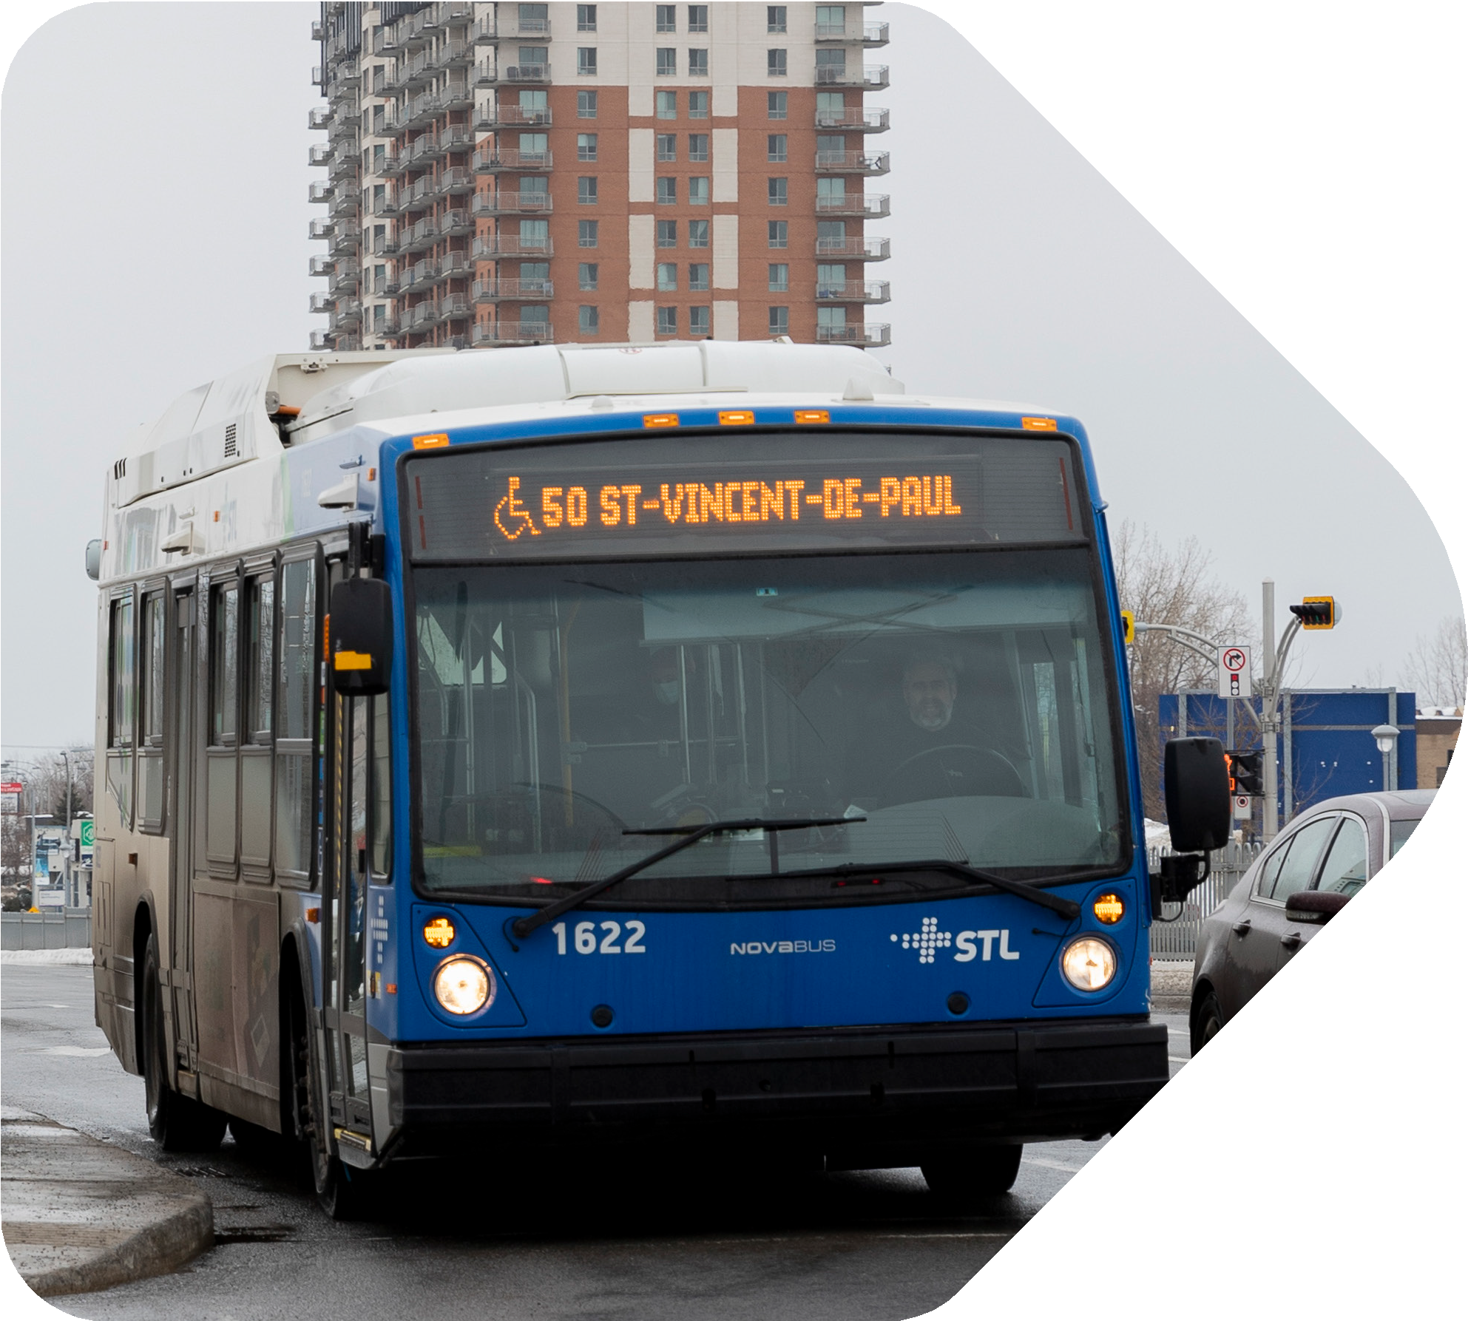

Mobility device specifications on the regular transit network
Buses are designed to accommodate only one person in a wheelchair at a time. Both manual and electric wheelchairs are accepted on STL buses.
For safety and accessibility reasons, only wheelchairs that meet the following criteria are allowed to use the access ramp to board buses on the STL’s regular transit network:
  - Maximum allowable width: 73.66 cm (29 in.)
  - Maximum allowable length: 116.84 cm (46 in.)
Accessible bus stops are marked with a wheelchair symbol on the bus stop sign. Buses with access ramps will also show that symbol next to the route number on the front display.
To find out which routes and stops are accessible, go to STLaval.ca or call the STL Customer Contact Centre at 450-688-6520.

Riders with limited mobility
Buses have priority seating for mobility-impaired riders. Priority seating areas are designated with appropriate signage. Don’t hesitate to request a priority seat if you
need it.
To make it easier for you to get on and off the bus, you can ask the driver to lower the bus floor to sidewalk level.

Fare information

Payment methods
  - Cash payment on board (exact change)
  - Credit and debit card
  - One-ride Bus ticket or All Modes ticket (paratransit paper ticket) depending on the service area
  - Monthly Bus or All Modes pass (loaded onto an OPUS card or a virtual pass)
For more information on fares and the fare schedule, go to:
artm.quebec/ en/fares-paratransit/
* Note that the Horizon 65+ pass is not valid outside Laval.
You must pay your fare each time you board, in accordance with existing
by-laws; otherwise you will be charged for the trips.
If you don’t pay the fare, you may be subject to a fine as indicated in our transit fare BY-LAW.

Paratransit paper tickets
Valid on the paratransit network only.
To find out where to purchase tickets, visit the website of the Autorité régionale de transport métropolitain at artm.quebec/en/points-of-sale/ or call our Customer Contact Centre at 450-688-6520.

Credit and debit card
Both debit and credit cards (Visa and Mastercard) are accepted on board paratransit vehicles. Note that American Express cards are not accepted.

Cash
You must have the exact fare ready. Drivers cannot give change.

Monthly pass loaded onto your OPUS card
You must load a monthly pass onto your OPUS card before your first trip for the current month.
You can purchase the next month’s pass starting on the 20th day of the current month to avoid waiting in line. The pass must be valid for three days before the first of the month so that information can be transferred between the various systems and the driver.
The OPUS card can hold monthly passes only.
No single fares (Occasionnelle cards) are accepted on the paratransit network.

Protecting your OPUS card
OPUS cards with photo ID are registered in our system, meaning that both the balance and card data are protected if the card is lost, damaged or stolen.
If you have a regular OPUS card (without photo ID), you need to register it so you can have any valid remaining fares transferred to a new card.
To do so, you must:
- Contact the Customer Contact Centre to request the OPUS CARD REGISTRATION FORM , or visit our website at
stlaval.ca/paratransit/rates-opus-card to download the form.
- Mail the form to:
SOCIÉTÉ DE TRANSPORT DE LAVAL
Service de transport adapté
2250, av. Francis-Hughes Laval QC H7S 2C3
or email it to transportadapte@stl.laval.qc.ca
IMPORTANT
Please call us at 450-688-6520 to give us your new OPUS card number.
VIRTUAL pass
If you use the paratransit service ONLY and make regular trips, the monthly virtual pass is the best option for you.
With a virtual pass, you can travel without ever having to use a ticket. To pay for your monthly pass, simply send a cheque by mail to the STL. Once your payment is received, we will notify the drivers that your fare has been paid for the month.

How to obtain a virtual monthly pass
- Prepare a cheque for the current fare and date it the first day of
the month for which you want your pass (go to the website or call
450-688-6520).
- Make the cheque out to Société de transport de Laval.
- Write your name, record number, and full address on the front of the cheque.
- Mail the cheque to:
SOCIÉTÉ DE TRANSPORT DE LAVAL
Service de transport adapté
2250, av. Francis-Hughes Laval QC H7S 2C3
We must receive your cheque no later than one week before the beginning of the following month. Otherwise, you will have to pay for each trip until we receive the cheque.
If you wish, you can also send us post-dated cheques to pay for multiple months. Make sure each cheque is dated the first day of each month.
If you later decide to cancel your subscription, your cheques will be returned to you.
Be sure to check the current fares when writing your cheques. Please note that fare rates are revised on July 1 of each year.

Points of sale – Single tickets and monthly passes
To find the nearest point of sale and the fare schedule:
- Go to the Tickets and Fares section on our website STLaval.ca/home
- Call the STL Customer Contact Centre at 450-688-6520.

On-time performance and pickup

When you book a ride, we will give you a 30-minute pickup window.
Make sure you write down the following:
- Service start and end dates for regular trips
- Confirmed pickup windows
- Pickup and drop-off locations
IMPORTANT!

Imminent vehicle arrival
To find out when the paratransit vehicle will be arriving, call the Reservations Centre at 450-973-3111 and select option 2.
No further calls will be made after our call if an event beyond our control delays the paratransit vehicle.
In some situations, you may not receive a call. That’s why you must be ready to board the paratransit vehicle at the beginning of your window.
NOTE

On-time performance
We do our best to be on time every time, but given the nature of the paratransit service, we ask that you be flexible so we can adhere to scheduled pickup and drop-off times.
NOTE
Delayed service
If the paratransit vehicle has not arrived by the end of your 30-minute pickup window, you can call the Reservations Centre at 450-973-3111,
option 2, to let us know that your vehicle is late.

Boarding
Before boarding
Parents or caregivers must make sure that paratransit users in their care are in a condition that allows them to travel safely. As a safety precaution, customers should never be forced to board a vehicle if they refuse to do so or are aggressive.

Vehicle arrival
Drivers will ring the doorbell to let you know that they have arrived.
If you live in a multi-unit building, you must wait for the driver in the lobby.
If you are in a public place, you must wait at the designated pickup point confirmed at the time of your reservation.
During boarding, parents or caregivers can assist the driver by helping customers identify themselves, by paying their fare, and by confirming their destination. They can also provide the driver with any information that could make boarding easier or increase the customer’s comfort and safety.

Assistance
If a paratransit user has an intellectual disability, a mental health condition or a specific medical condition, we are required to enter a note for assistance in the customer’s record to ensure the customer’s safety. This procedure is mandatory and means that, when boarding, customers who have that note in their records must be assisted by a person in charge (aged 14 and over), who can confirm their identity and destination. The caregiver or parent must provide the driver with any information that could make boarding easier or ensure the customer’s comfort and safety. A person in charge must also wait for the customer at the drop-off location to ensure the customer’s safety.
To ensure the safety of customers with an intellectual disability, autism spectrum disorder (ASD) or a mental health condition, the driver will always confirm the identity of the person in charge.
This procedure is designed to protect vulnerable customers and make sure each trip ends safely.
Paratransit users who are self-sufficient enough to be left alone at all times may be exempted from the assistance requirement. To obtain such an exemption, please fill out the form “Attestation of autonomy and authorization to leave a paratransit user unattended at their destination” (PDF) on our website. If needed, call the STL Customer Contact Centre at 450-688-6520.

Eligibility card
For safety reasons, customers must show their paratransit eligibility cards or be able to properly identify themselves (alternatively, the person in charge can provide the required information).

Assistance provided by drivers
Drivers will provide assistance with entering or leaving the vehicle. They will:
  - Escort you to the vehicle from the accessible door at your pickup location and from the vehicle to the accessible door at your drop-off location.
  - Help you get in and out of the vehicle.
  - Stow your mobility device.
  - Take you through the doors located on the ground floor of the pickup or drop-off location.
Drivers will not go to any upper floors and must never lose sight of their vehicles. They are not allowed to wait for you and they cannot change your reservation. If you need to reschedule a ride, please contact the Reservations Centre at 450-973-3111.
You must be able to transfer to the vehicle seat on your own or with minimal assistance unless you are permanently in a wheelchair.
Unfortunately, drivers cannot assist you up or down more than one step if you are in a wheelchair and there is no access ramp. You will have to go through the doorway on your own or with help from someone other than the driver.

Location accessibility
The pickup and drop-off locations must be accessible and meet your accessibility needs.
If an access ramp is considered unsafe, your trip may be cancelled. We may ask you to have the ramp modified so that it meets safety requirements.
In the winter, make sure the pickup and drop-off locations are cleared of snow and ice before the driver arrives. Otherwise, your trip may be cancelled, unless you are able to reach the vehicle on your own.

Your responsibilities

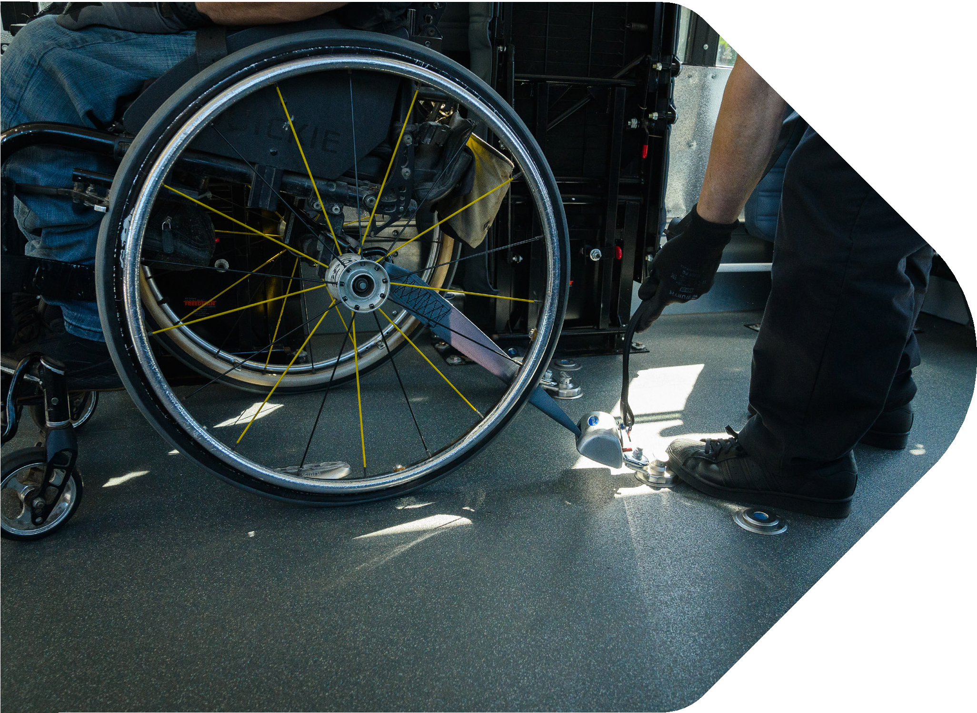

Staying seated in your mobility device during the ride: Conditions and safety
We ask that you take the following precautions with your mobility device. Keep the following in mind:
  - Your mobility device must be clean and in good working order.
  - Your manual or electric wheelchair must be equipped with a four-point tie-down system for transportation. The tie-down anchor points are designed to secure the wheelchair to the vehicle floor using the wheelchair straps and occupant restraint systems, ensuring everyone’s safety. If your manual or electric wheelchair does not have a four-point tie-down system, you will be required to sit on the vehicle seat, and you may have to leave your wheelchair behind.
  - Before taking a paratransit trip seated in your mobility device, check the device manufacturer’s manual to make sure such use is authorized. It is important to comply with the manufacturer’s recommendations for your safety and the safety of other passengers. The STL reserves the right to check compliance.
  - Your mobility device must fit on the lift platform, meaning that it cannot be more than 137 cm (54 in.) long by 84 cm (33 in.) wide.
  - The weight of your mobility device combined with your own weight must not exceed 364 kg (800 lb.).
IMPORTANT
No flags, bags or other accessories may be attached to mobility devices.

Using a three- or four-wheel scooter
If you use a three- or four-wheel scooter, you may not remain seated in it while travelling on board the paratransit vehicle. In addition, you must be able to transfer from the scooter to the vehicle seat and take a few steps inside the vehicle.

Using a wheelchair without tie-downs
If you use such a mobility device, you must transfer over to the vehicle seat and be able to do so on your own.

Wearing seat belts
Seat belts must be worn at all times during transport. If you are unable to fasten the belt yourself, the driver must assist you.
If you refuse to wear a seat belt, your trip will be cancelled, and your eligibility will be reassessed.
Only individuals who have a seat belt exemption certificate issued by the Société de l’assurance automobile du Québec may ride without wearing a seat belt.
However, they must provide the STL Paratransit Service with a copy of the certificate ahead of time.

Travelling with service animals and pets
Guide or service dogs
If you plan to travel with a guide or service dog, please let us know when you book your ride.
You are responsible for keeping an eye on and controlling the dog at all times. Your dog must always wear a harness.

Pets
Pets must travel in a secure pet carrier placed on your lap, in accordance with the same rules that apply to luggage. If you plan to travel with a pet, call us at 450-973-3111 to let us know when you book your ride.

Bringing carry-on items on board
At times, you may have to carry various items with you. For safety reasons, such items must be carried by you or the person accompanying you. Please be aware of the rules below and make sure you follow them.

Luggage, grocery bags, and shopping bags
For safety reasons, luggage and grocery or shopping bags are permitted only if the following rules are observed:
  - You are able to carry the items yourself.
  - The items do not take up any extra space in the vehicle.
  - The items are securely attached or held by you.
The driver may refuse to let you board the vehicle if you have items you cannot carry yourself.
Trunk space is reserved for mobility devices belonging to passengers who are already on board or who will be picked up later.
No items other than a mobility device may be placed in the trunk of a taxi.
Shopping carts are not allowed on board paratransit vehicles.
Have you considered using a delivery service for your groceries and other purchases?

Exceptions for certain destinations
Luggage is allowed on board exclusively for passengers travelling in accessible vehicles to one of the following destinations only:

  - Montréal–Pierre Elliott Trudeau International Airport
  - Central Station (train):
895 De La Gauchetière Street West
  - Dorval VIA Rail Station:
755 Montréal-Toronto Boulevard, Dorval
  - Gare d’autocars de Montréal:
1717 Berri Street, Montreal
  - Sauvé Station:
420 De Port-Royal Street East
  - Mégabus bus terminal:
997 Saint-Antoine Street West, Montreal
  - Camp Papillon:
7275 Sherbrooke Street East, signposts 24-25, Montreal
  - The Grand Quay at the Port of Montreal:
200 De la Commune Street West, Montreal

If you plan to bring a suitcase, please let us know when you book your ride.

Additional information

Standards of conduct on board paratransit vehicles
The paratransit team strives to provide on-time, safe, and reliable transportation services every day while maintaining a respectful environment.
We expect the same conduct from our customers as you might expect from our employees or representatives.
Please be advised that passengers who conduct themselves in a way that violates the rules in this guide and the standards in By-law CA-9 may face restrictions.
Unacceptable behaviour may negatively impact:
  - Your safety
  - The safety, comfort or well-being of other passengers
  - The driver’s safety
  - Vehicle integrity
  - Routine paratransit operations
We understand that exceptional circumstances that are beyond your control may arise. That’s why, before taking any action, an STL representative will contact you to assess the situation and notify you of the next steps, if any.

Trip duration
The duration of a paratransit trip is similar to that of a regular bus trip, not counting the time required to board and exit the paratransit vehicle.
However, total travel time is subject to variations in road or weather conditions and any other circumstances that are beyond our control, such as time spent waiting for a customer.

In the event of an accident
Should an accident occur during a trip, the STL will contact your family. If you are injured while using the STL’s paratransit services, you must:

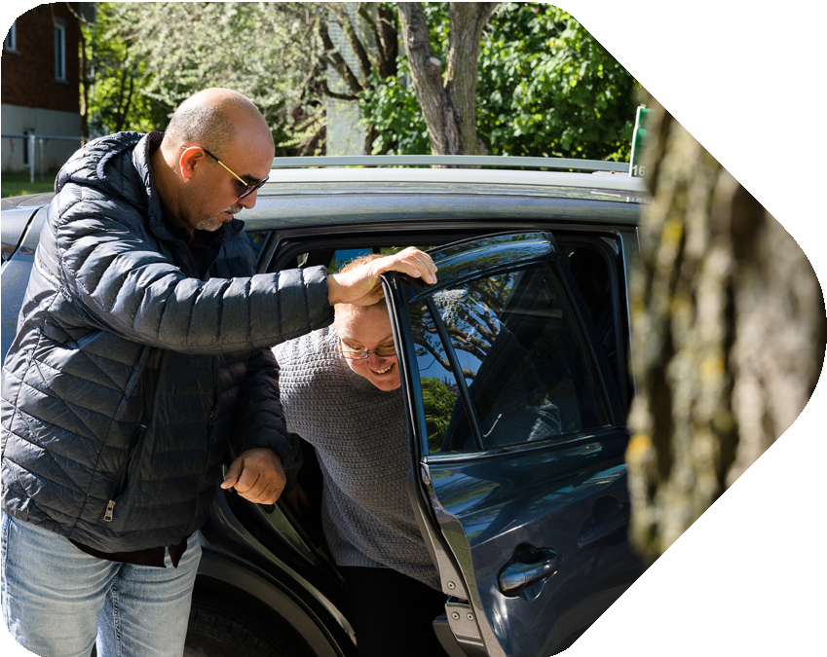
  - Notify the driver
  - Consult a doctor
  - Call the Customer Contact Centre at 450-688-6520 to report the incident
  - Contact the Société de l’assurance automobile du Québec at 514-873-7620 to file a claim.

Your record
Updating your record
Please call the STL Customer Contact Centre at 450-688-6520 if you need to update the information we have on record for you:

  - Address
  - Phone number
  - Medical condition
  - Mobility device (e.g., wheelchair, cane, walker or rollator)
  - Emergency contact
  - Need for a support person
  - Level of independence
  - Other

NOTE
Any updates to your record to reflect changes in your diagnosis, disability, need for a support person or any other special need may trigger an eligibility review or a request for written proof from a healthcare professional.
If you do not use the paratransit service for more than two years, your account will be automatically deactivated. To reactivate it, please contact the STL at 450-688-6520. Reactivating your account may result in your eligibility being reviewed.

Moving outside of Laval?
Refer to the “Paratransit” section of our website and complete the form Authorization to release a paratransit service user’s file to another public transit provider due to the user relocating outside the City of Laval.

Visitors
- Residents living in the area served by the ARTM:
Please contact your local transportation agency if you reside outside Laval, but within the ARTM’s service area, and want to travel to Laval. Your local agency is responsible for coordinating transportation with the STL.

- Residents of Quebec (outside the ARTM’s service area):
Please contact the STL at 450-688-6520 for more information.

- Non-Quebec residents
To be eligible, you must use a wheelchair on a permanent basis. Please contact the STL at 450-688-6520 for more information.

Tips
Since paratransit is a public service, tipping is not allowed.

Feedback and penalties

Feedback
Your feedback is important to us. It is the main source of information we use to improve our services. Feel free to submit any suggestions and share your concerns by calling the Customer Contact Centre at 450-688-6520.

Penalties
Customers who repeatedly violate the rules outlined in this guide may face restrictions up to and including suspension of service.
Because we understand that exceptional circumstances may arise occasionally, we make sure to assess each situation before imposing any restrictions.

Contact us

For all travel-related inquiries (questions, reservations, changes, and cancellations):
Reservations Centre
Telephone: 450-973-3111

Lost and found
If you lost an important or valuable item during a trip (such as a cell phone, laptop, tablet, medication, keys, prescription glasses, hearing aids, ID or a mobility device), please contact us the same day at 450-973-3111, option 2, to report the lost item.
Once notified, we will do everything we can to locate your item and determine the best way to return it to you. However, despite our best efforts, we cannot guarantee that lost items will be recovered.
For any other non-priority items, call 514-786-4636 and select option 7 in the menu. Hours: Monday to Friday, 8:00 a.m. to 6:00 p.m.

For information on our services, complaints, comments, and requests

STL Customer Contact Centre
Telephone: 450-688-6520
Monday to Friday: 7:00 a.m. to 7:00 p.m.
Saturday, Sunday and statutory holidays: 8:00 a.m. to 5:00 p.m.
The Customer Contact Centre will record a request under your name and forward it to the paratransit administration. Note that all requests are reviewed and processed by the paratransit team. However, due to the high volume of requests, the team cannot provide regular updates.

To submit an eligibility form or any other relevant document
Service de transport adapté de la STL
2250, avenue Francis-Hughes
Laval (Québec) H7S 2C3 transportadapte@stl.laval.qc.ca

Société de transport de Laval
2250, avenue Francis-Hughes
Laval (Québec) H7S 2C3
STLaval.ca
Version: March 2026

